Day 32 - 03rd Sept 2025
Mohammed Arsalain
mobarsal@amazon.com

Hope you have received Credentials for accessing AWS cloud

Login to cloud environment

Change region to Asia - Mumbai

Search for DynamoDB

Task 1:

Create a table with few attributes..
Also add some records..
Take a ss of it and paste it

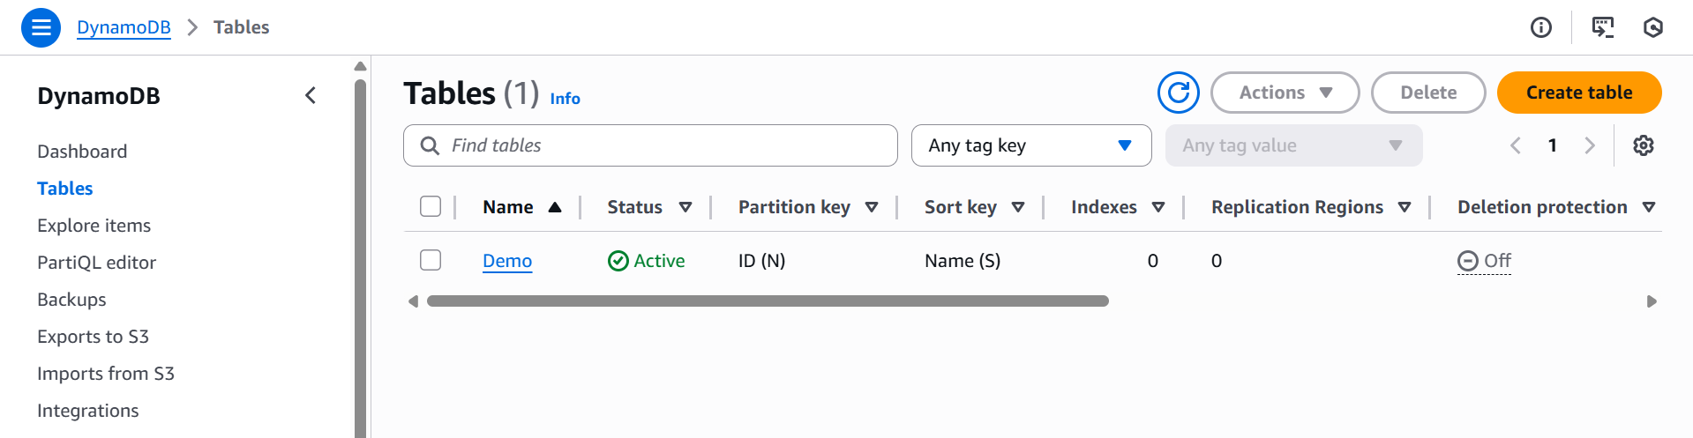

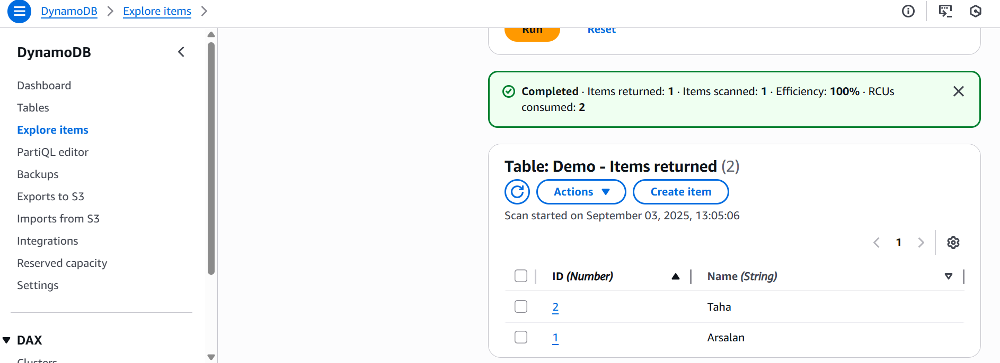
Info Box:

Projects doc link.. ALL Projects 10 Day plan

https://docs.google.com/document/d/1gOzEONAVHm-DifF-RhEy_PwsdjCnkLzi/edit?usp=sharing&ouid=103020917863623365252&rtpof=true&sd=true

Batch 1 projects

https://docs.google.com/spreadsheets/d/16Ia3jG_uJtTPvpDQTv-XW3-0OE1qagjD5pgB9TYcKDc/edit?usp=sharing

